International Symposium on
Carrier Interactions in
Mesoscopic Systems 2001
(CIM 2001)

February 13-14, 2001
NTT Atsugi R&D Center

Organizing and Program Committee

Y. Hirayama (NTT), Chairman
G. E. W. Bauer (TU Delft)
K. Hirakawa (Univ. Tokyo)
N. Imoto (SOKEN)
L. P. Kouwenhoven (TU Delft)
J.-P. Leburton (Univ. Illinois)
J. E. Mooij (TU Delft)
K. H. Ploog (Paul-Drude Institute)
S. Tarucha (Univ. Tokyo, NTT)
H. Yokoyama (ETL)
K. Muraki (NTT), Secretary

Sponsors

NEDO
CREST (FEMD)-JST
NTT Basic Research Laboratories
NTT Atsugi R&D Center

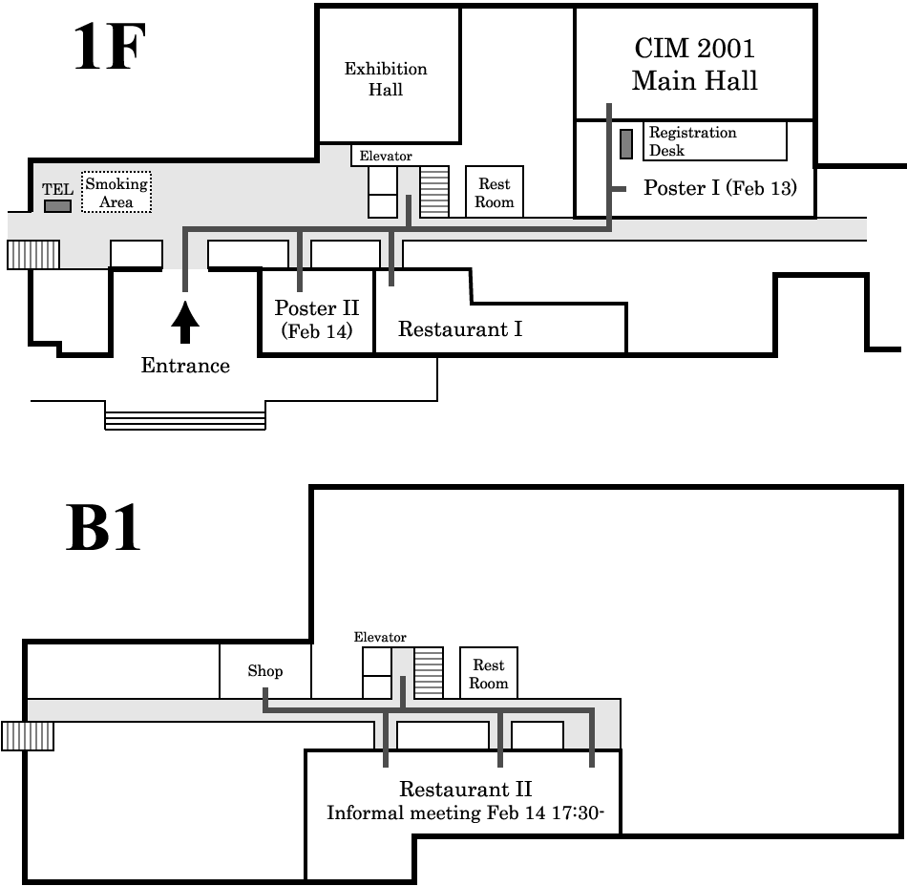

Registration & Welcome Reception
Feb 12 (Mon) 18:00-21:00
Atsugi Royal Park Hotel
2F, Room 'Akatsuki'

Banquet
Feb 13 (Tue) 19:00 start
Atsugi Royal Park Hotel
3F, Room 'Sagami-nishi'

Informal Meeting
Feb 14 (Wed) 17:30-
NTT R&D Center
B1, Restaurant II

Atsugi Royal Park Hotel
Phone: (046) 221-0001

Atsugi Urban Hotel
Phone: (046) 222-3344

CIM2001 Secretariat
Phone: (046) 240-3440 (Hirayama)
(046) 240-3478 (Muraki)
Fax: (046) 240-4727
E-mail: cim2001@will.brl.ntt.co.jp
Homepage:
http://www.brl.ntt.co.jp/events/cim2001/

Oral Session (Feb 13, Tue)

10:00-10:25 | Opening Address

10:00-10:15
Y. Hirayama (NTT), CIM2001 Chair
Representatives from NEDO and CREST

10:15-10:25
S. Ishihara, Director of NTT Basic Research Laboratories

10:30-11:15 | Opening Session

Electron and spin interactions in low dimensional systems
K. von Klitzing (plenary)
Max-Planck-Institut für Festkörperforschung, Stuttgart, Germany

11:15-11:35 Coffee Break (20 min)

11:35-13:05 | Session A: Quantum Hall Systems

11:35-12:05
A-1 Interlayer coherence in bilayer quantum Hall systems
Z. F. Ezawa (invited)
Department of Physics, Tohoku University, Japan

12:05-12:35
A-2 Quantum Hall ferromagnets: the big picture
A. H. MacDonald (invited)
Department of Physics, University of Texas at Austin, USA

12:35-13:05
A-3 Quantum Hall ferromagnet: integer quantum Hall effect due to Coulomb interactions
K. Muraki
NTT Basic Research Laboratories, Japan

13:05-14:00 Lunch (55 min)

14:00-15:30 | Session B: Electron-Hole Systems

14:00-14:30
B-1 The controlling exciton Bose condensate and phonon laser
Y. Lozovik (invited)
Institute of Spectroscopy, Russian Academy of Science, Russia
14:30-15:00
B-2 InAs/GaSb based interacting electron-hole system in high magnetic field
K. Takashina (invited)
Department of Physics, Clarendon Laboratory, University of Oxford, UK

15:00-15:30
B-3 Magnetic electron-hole plasmas in carbon nanotubes
G. E. W. Bauer
Department of Applied Physics and DIMES, Delft University of Technology, the Netherlands

15:30-15:50 Coffee Break (20 min)

15:50-16:50 | Session C: Carrier Interactions in Magnetic Media

15:50-16:20
C-1 Ferromagnetic transition mechanisms in III-V diluted magnetic semiconductors
K. Hirakawa
Institute of Industrial Science, University of Tokyo, Japan
CREST, Japan Science and Technology Corporation, Japan

16:20-16:50
C-2 Nuclear spin polarization/relaxation via interactions with two-dimensional
electron systems
Y. Hirayama
NTT Basic Research Laboratories, Japan

16:50-18:20 | Poster Session I  (Main Hall Lobby)

18:20 Shuttle Bus leaves for Atsugi Royal Park Hotel

19:00-21:00 | Banquet  (Atsugi Royal Park Hotel)
Oral Session (Feb 14, Wed)

9:30-11:00 | Session D: Physics and Fabrication/Probing  Techniques in Nanostructures

9:30-10:00
D-1 Magnetically modulated two dimensional electron systems,
micro-Hall-magnetometry and composite fermions
D. Weiss (invited)
Universitaet Regensburg, Experimentelle und Angewandte Physik, Germany

10:00-10:30
D-2 Fabrication and properties of uncoupled and coupled quantum wire and
dot structures on high-index GaAs substrates
K. H. Ploog
Paul Drude Institute for Solid State Electronics, Germany

10:30-11:00
D-3 Advancement of scanning probe microscopy for functional study of
quantum nanostructures
H. Yokoyama
Electrotechnical Laboratory, JST-CREST, Japan

11:00-11:20 Coffee Break (20 min)

11:20-12:20 | Session E: Spin States in Quantum Dots

11:20-11:50
E-1 Control and applications of two-electron states in quantum dot structures
S. Tarucha
Department of Physics, University of Tokyo, Japan

11:50-12:20
E-2 Spin effects and exchange engineering in coupled quantum dots
J. P. Leburton
Department of Electrical and Computer Engineering and Beckman Institute,
University of Illinois at Urbana-Champaign, USA

12:20-13:20 Lunch (60 min)

13:20-14:20 | Session F: Kondo Effect in Quantum Dots

13:20-13:50
F-1 Kondo effect in quantum dots: recent developments
Y. V. Nazarov (invited)
Department of Applied Physics and DIMES, Delft University of Technology, the Netherlands
13:50-14:20
F-2 The Kondo effect in lateral and vertical quantum dots
W. G. van der Wiel
Department of Applied Physics, DIMES, and ERATO Mesoscopic Correlation Project,
Delft University of Technology, the Netherlands

14:20-15:50 | Poster Session II  (Presentation Room)

15:50-17:20 | Session G: Qubit Manipulation

15:50-16:20
G-1 Amplifying quantum signals with the single-electron transistor
M. Devoret (invited)
Quantronics group, CEA-Saclay, France

16:20-16:50
G-2 Collective/individual manipulation and entanglement for qubit information control
N. Imoto
The Graduate University for Advanced Studies, Japan

16:50-17:20
G-3 Measurements on persistent-current qubits
J. E. Mooij
Delft University of Technology, the Netherlands

17:20-17:30 | Closing Address

Y. Hirayama, CIM 2001 Chair

17:30- | Informal Meeting with Food & Drink  (B1 Floor, Restaurant II)
Poster Session I (Feb 13, Tue)

TP-01 Electron removal spectrum and elementary excitations in fractional quantum
Hall systems
S. Suzuki, Y. Kato and Y. Kuramoto
Department of Physics, Tohoku University, Japan

TP-02 Properties of compressible strips at fractional quantum Hall plateaux
K. Oto, T. Matsubayashi, K. Arai, S. Takaoka and K. Murase
Graduate School of Science, Osaka University, Japan

TP-03 Various ν = 2/3 quantum Hall states in bilayer system
N. Kumada, H. Azuhata, S. Nagahama, D. Terasawa, Y. Shimoda, A. Sawada,
Z. F. Ezawa, K. Muraki, T. Saku and Y. Hirayama
Department of Physics, Tohoku University, Japan

TP-04 Investigation of Rashba spin-splitting energies in InGaAs/InAlAs
heterostructures using anti-weak-localization analyses
T. Koga, J. Nitta, T. Akazaki and H. Takayanagi
NTT Basic Research Laboratories, Japan

TP-05 Quantum transport in narrow wire FETs made at spin-splitted
In_{0.75}Ga_{0.25}As/In_{0.75}Al_{0.25}As heterointerfaces
S. Yamada, Y. Sato and S. Gozu
School of Materials Science, JAIST, Japan

TP-06 Spin-orbit interaction in an InAlAs/InAs heterostructure
K. Yoh, S. Abe, T. Doi, Y. Katano, H. Ohno, K. Sueoka and K. Mukasa
Research Center for Interface Quantum Electronics, Hokkaido University, Japan

TP-07 Quantum point contact with a widely tunable range for the electron density
K. Hashimoto, S. Miyashita, T. Saku and Y. Hirayama
NTT Basic Research Laboratories, CREST-JST, Japan

TP-08 Electron coupling in weakly and strongly coupled quantum point contacts
K. J. Friedland, T. Saku, Y. Hirayama and K. H. Ploog
Paul Drude Institute for Solid State Electronics, Germany

TP-09 Quantum transport and gate-controlled mode hybridization in GaAs-based
Schottky in-plane gate coupled quantum wire transistors
S. Kasai, M. Iwaya, M. Yumoto and H. Hasegawa
Research Center for Interface Quantum Electronics and Graduate School of Electronics and Information Engineering, Hokkaido University, Japan

TP-10 Magnetic minibands and conductance oscillations in a quantum wire with
short period potential modulation
T. Asayama, Y. Tokura, S. Miyashita, M. Stopa and S. Tarucha
Department of Physics, University of Tokyo, Japan

TP-11 Hund's rule in a spherical artificial atom
Y. Asari, H. Tamura and K. Takeda
Department of Material Science, School of Science and Engineering, Waseda University, Japan
TP-12 Three-dimensional analysis of the electronic structure of cylindrical vertical
quantum dots
P. Matagne, J. P. Leburton, D. G. Austing and S. Tarucha
Beckman Institute for Advanced Science and Technology, University of Illinois at Urbana-Champaign, USA

TP-13 Magnetic field induced transitions in the few-electron ground states of
artificial molecules
S. Amaha, D. G. Austing, Y. Tokura, K. Muraki, K. Ono and S. Tarucha
Department of Physics, University of Tokyo, Japan

TP-14 Mean field theory for integer-spin Kondo effect in quantum dots
M. Eto and Y. V. Nazarov
Department of Applied Physics / DIMES, Delft University of Technology, the Netherlands

TP-15 Magnetoconductance of coupled quantum dots in the Kondo region
T. Aono and M. Eto
The Institute of Physical and Chemical Research (RIKEN), Japan

TP-16 Suppression of the Kondo effect in a quantum dot by microwave radiation
J. M. Elzerman, W. G. van der Wiel, S. De Franceschi, D. Goldhaber-Gordon
and L. P. Kouwenhoven
Department of Applied Physics / DIMES, Delft University of Technology, the Netherlands

TP-17 Aharonov-Bohm oscillations induced by a coil current
K. Tsubaki
NTT Basic Research Laboratories, Japan

TP-18 Electro-magnetic Aharonov-Bohm effect in a 2-D electron gas ring
W. G. van der Wiel, E. W. G. M. Huizeling, J. M. Elzerman, S. De Franceschi,
T. Fujisawa, S. Tarucha and L. P. Kouwenhoven
Department of Applied Physics / DIMES, Delft University of Technology, the Netherlands

TP-19 Nonlinear response and dephasing in mesoscopic rings and dots under
an external ac pumping
V. I. Yudson
Center for Frontier Science, Chiba University, Japan
Institute of Spectroscopy, Russian Academy of Sciences, Russia

TP-20 Charge fluctuations on a ultrasmall superconductor
Y. Utsumi, H. Imamura, M. Hayashi and H. Ebisawa
Graduate School of Information Sciences, Tohoku University, Japan

TP-21 N-qubit system in capacitively coupled semiconductor quantum dots
T. Tanamoto
Corporate R & D Center, Toshiba Corporation, Japan

TP-22 Entanglement of quantum dots in the spin van der Waals model
A. Miranowicz, S. K. Ozdemir, M. Koashi, N. Imoto and Y. Hirayama
CREST-JST, School of Advanced Sciences, Graduate University for Advanced Studies (SOKEN), Japan
Nonlinear Optics Division, Institute of Physics, Adam Mickiewicz University, Poland

TP-23 Electro-mechanical properties of freestanding InAs membranes fabricated from
InAs/GaAs (111)A heterostructures
H. Yamaguchi, R. Dreyfus, S. Miyashita and Y. Hirayama
NTT Basic Research Laboratories, Japan
Poster Session II (Feb 14, Wed)

WP-01 High mobility electron gas wafer-fused on LiNbO₃
K. J. Friedland, A. Riedel, H. Kostial, R. Hey and K. H. Ploog
Paul Drude Institute for Solid State Electronics, Germany

WP-02 Transport properties in InAs/AlSb/GaSb heterostructures
K. Suzuki, S. Miyashita and Y. Hirayama
NTT Basic Research Laboratories, Japan

WP-03 Electronic structures of a single-layer and a double-layer two dimensional
electron systems in tilted magnetic fields investigated by cyclotron
resonance spectroscopy
H. Aikawa, S. Takaoka, K. Oto, K. Murase, S. Shimomura, S. Hiyamizu,
T. Saku and Y. Hirayama
Graduate School of Science, Osaka University, Japan

WP-04 Edge states and bulk conduction properties of Si-MOSFET in the quantum
Hall regime
K. Arai, T. Matsubayashi, K. Oto, S. Takaoka and K. Murase
Department of Physics, Graduate School of Science, Osaka University, Japan

WP-05 Surface-acoustic-wave attenuation in asymmetric two-layer systems in
the quantum Hall regime
Y. Takagaki, E. Wiebicke, K. J. Friedland and K. H. Ploog
Paul Drude Institute for Solid State Electronics, Germany

WP-06 Model for spin-transport in resonant ferromagnet/2-dimensional electron
gas/ferromagnet structures
Th. Schaepers, J. Nitta, H. B. Heersche, T. Koga and H. Takayanagi
NTT Basic Research Laboratories, Japan

WP-07 Fabrication and characterization of Fe/InAs hybrid structure
K. Yoh, H. Ohno, Y. Katano, A. Subagyo, T. Doi, K. Sueoka and K. Mukasa
Research Center for Interface Quantum Electronics, Hokkaido University, Japan

WP-08 The electron-electron interactions in the spin transport dynamics of
a two-dimensional electron gas
Y. Takahashi, K. Shizume and N. Masuhara
Department of Electrical Engineering ,Yamagata University, Japan

WP-09 Electronic pressure on ferromagnetic domain wall
Y. Tokura and G. Tatara
NTT Basic Research Laboratories, Japan

WP-10 Transport characteristics of electrons in weak short period two-dimensional
potential arrays
A. Kawaharazuka, T. Saku, Y. Tokura, Y. Horikoshi and Y. Hirayama
NTT Basic Research Laboratories, Japan
School of Science and Engineering, Waseda University, Japan

WP-11 Magnetic field effects on the flat-band ferromagnetism on a kagome dot array
T. Kimura, H. Tamura, K. Shiraishi and H. Takayanagi
NTT Basic Research Laboratories, Japan
WP-12 Quasi-periodic spin polarization in realistic quantum dots
M. Stopa
Tarucha Mesoscopic Correlation Project, ERATO-JST, Japan

WP-13 Spectroscopy of electronic states in self-assembled InAs quantum dots formed
on GaAs pyramids
H. An, J. Motohisa and T. Fukui
Research Center for Interface Quantum Electronics, Hokkaido University, Japan

WP-14 Influence of different starting materials on transport through self assembled dots
D. G. Austing, R. Hill, A. Patane, M. Henini, P. Main, L. Eaves and S. Tarucha
NTT Basic Research Laboratories, Japan

WP-15 Strong quantum confinement characterization of vertically stacked InAs
self-assembled quantum dots in Al_{0.5}Ga_{0.5}As barrier
S. Li, K. Koike and M. Yano
New Materials Research Center, Osaka Institute of Technology, Japan

WP-16 Crossover between singlet - and triplet-state in a quantum dot with Kondo
coupling
W. Izumida
Tarucha Mesoscopic Correlation Project, ERATO-JST, Japan

WP-17 The Kondo effect in a quantum dot with only one electron
Y. Kitamura, S. Sasaki, W. Izumida, K. Ono and S. Tarucha
Department of Physics, University of Tokyo, Japan

WP-18 Transient current spectroscopy of lateral and vertical quantum dots
T. Fujisawa, Y. Tokura, Y. Hirayama, D. G. Austing and S. Tarucha
NTT Basic Research Laboratories, Japan

WP-19 THz emission from Bloch oscillations in wide miniband superlattices
Y. Shimada, S. Madhavi and K. Hirakawa
Institute of Industrial Science, University of Tokyo, Japan

WP-20 Bounds on bipartite entanglement shared among many qubits
M. Koashi, V. Buzek and N. Imoto
CREST-JST, School of Advanced Sciences, The Graduate University for Advanced Studies (SOKEN), Japan

WP-21 Optical state truncation: a proposal for experimental realization
S. K. Ozdemir, A. Miranowicz, M. Koashi and N. Imoto
CREST-JST, School of Advanced Sciences, The Graduate University for advanced Studies (SOKEN), Japan

WP-22 Luminescence spectroscopy of modulation-doped AlGaAs/GaAs quantum
structures using low-temperature scanning near-field optical microscope
T. Tokizaki, H. Kawashima, T. Shigefuji, T. Inoue and H. Yokoyama
Electrotechnical Laboratory, CREST-JST, Japan

WP-23 Imaging of zero-dimensional states in InAs nanostructures using
low-temperature scanning tunneling microscopy
K. Kanisawa, M. J. Butcher, Y. Tokura, H. Yamaguchi and Y. Hirayama
NTT Basic Research Laboratories, Japan

